Digestive System

The digestive system is a coiled, muscular tube stretching from the mouth to the anus. Several specialized compartments occur along this length: mouth, pharynx, esophagus, stomach, small intestine, large intestine, and anus. The accessory organ which associated with digestive system salivary glands, tongue, teeth, liver, spleen and pancreas. The function of the digestive system: Secretion, digestion, absorption and movement. Diagnosis of abnormalities of digestive system:

1. abdominal palpation.

2. oral examination .

3. rectal palpation .

4. percussion and auscultation.

5. radiography and endoscopy.

6. In addition to that sampling and analysis of saliva, stomach content, feces, abdominal fluid may yield information of importance in differential diagnosis also hematological examination for complete blood count and chemical component is used in differential diagnosis.

**Oral cavity**: Although few diseases affect the oral cavity and esophagus. The most common oral cavity abnormality that affects production is dental disease. To perform a complete oral examination, the clinician should physically restrain or sedate the animal and place an oral speculum or gag in the mouth to enhance the visualization of the oral cavity.

Mouth: Is the first portion of the alimentary canal that receives food and begins digestion by mechanically breaking up the solid food particles into smaller pieces and mixing them with Saliva. . The mouth was bounded laterally by the cheeks, dorsally by the hard palate, ventrally by the body of the mandible and the mylohyoid muscles, caudally by the soft palate.

**Affection of oral cavity: General clinical signs of oral diseases: ptyalism, reluctance to eat, weight loss, dysphagia and oral hemorrhage. A variety of aerobic and anaerobic bacteria present. Dilute povidone- iodine solution or 2% chlorhexidine irrigation can be used.**

1. **Abscesses** of the oral cavity associated with actinobacillosis or actinomycosis infection, appropriate medical therapy can be undertaken after bacteriological examination to confirm diagnosis.

2. **Traumatic lesion**: The mouth may be wounded by the penetration of sharp or pointed bodies entering through the cheeks or sharp teeth lacerating the cheeks and lips or by fragment of bone in fracture of the jaw also may be foreign bodies taken in food such as nails, needles, pins. These wounds are only serious when an important vessel or nerve was involved. Ordinary wounds of the mouth heal rapidly. It is only necessary to clean them after feeding. A foreign body must be removed, **debridement, antiseptic**. When fracture of mandible, reduction and immobilization of the fracture was achieved by the use of transverse pins, bone plate or combination of both with wiring and external fixation. In cattle: Foreign bodies lodged in the oral cavity or pharynx is common problems.

Clinical signs:

a. Salivation and drooling.

b. The animal will try to eat but will not be able.

c. If the foreign body has been present for some time, the animal will be very thin. Treatment: Removal of foreign body by manually or surgical operation depends on the type of foreign body encountered .

3. **Neoplasm**: Usually pedunculated may results in intermittent blockage of the oral or nasal pharynx. Epulis was located primary tumor with a malignant tendency generally on the gum adjacent to the upper or lower incisors which displaces the lip with its increasing size and tend to be recognized at an early stage. A tumor of the floor of the mouth may involve the under surface of the tongue, the lower jaw bone, and other tissues of the area. A small lesion detected early can be controlled in most cases by excision of the growth and radiation therapy.

Treatment:

a. Excised by wire snare (Pedunculated) .

b. Surgical resection .

c. Cryotherapy.

**Lips:** The lips mark the transition from mucous membrane to [skin](http://www.answers.com/topic/skin), which covers most of the body. In cattle thick and relatively stiff, but the middle of the upper lip form the smooth muzzle on which the clear fluid secreting nasolabial glands open. In sheep is thin and mobile.

**1-Hare lip**: This is a cleft in the upper lip which often runs into the nostril, may be unilateral or bilateral and is often associated with cleft palate. Cleft of the lower lip is rare and usually occurs on the midline. The defect may also involve the palate alone, affecting the hard or soft components of the palate, or both. Hare lip may be due to incidental or genetic origin. It occurs in all species and appears to be most common in calves.

**Treatment**: The edges of the cleft are excised and the incision sutured.

2**. Trauma**: Wounding of the lips is fairly frequent after car accident, contact with sharp protruding objects, and attack by dogs. Because of the excellent blood supply, healing is usually rapid. In sever laceration or loss of substance, plastic surgery is called for to preserve the function of the lips. Repair requires careful surgical apposition of the lip margins. Mucosa and skin layers are sutured separately.

**3. Avulsion** of the lower lip from the gingival margin: in sever laceration, reconstructive surgery is indicated this can be problematical because of the high muscular content and movement in the lips and tongue. Careful attention should be paid to normal principle of wound cleaning and debridement. Tension should be tied on the skin surface rather than over the mucous membrane.

4.**Retraction of the lips**: Sometimes as the results of injury and consequent development of much fibrous tissue between the lip and the gum, cicatricle contraction retracts the lip and prevents it's meeting with the other one. This may be remedied by making an incision between the gum and the lip.

**5. Tumor**: papilloma or warts are common on the lips of the horse and are less frequently seen on those of cattle. The tumors form in clusters and are various dimensions. They cause salivation and usually an offensive smell from the mouth.

Treatment: Excision.

**Cheeks**: The cheeks form the sides of the mouth, they are continuous in front with the lips and are attached to the alveolar borders of the bones of the jaw.

1.**Tumor** : occasionally occur and may present special management problems because of oral fistulation associated with the lesion itself as a result of therapy. Treatment: cryosurgery.

2. **Wound**: penetrating wound of cheeks or loss of substance from the edge of the lips.

Treatment: Repair under general anesthesia, the wound edge is excised and a horizontal incision was made above and below the hole, somewhat larger than the diameter of the wound. The hole is closed with deep interrupted silk sutures. The horizontal incisions are sutured.

**Hard palate:** The osseous base of the hard palate is formed by the pre – maxilla , maxilla and palatine bones , and its borders are the alveolar arches.

Cleft hard palate: Cleft in roof of the mouth may be congenital, but the hereditary basis of the anomaly is less well defined.

Clinical signs:

1. Dysphasia with reflex of milk or food material through the nostril.
2. Direct visual or by endoscope.
3. Aspiration pneumonia.

Treatment: The hard palate can be approached through :

1. Mandibular symphysiotomy.
2. Oral approach.
3. Pharyngotomy (limited exposure).

Small caudal defects of hard palate can be repaired using a mucoperiosteal sliding flap technique. Large cleft of the hard palate may be best repaired by the mucoperiosteal reflected flap technique. In case mandibular symphysiotomy closure of oral mucosa prior to fixation of mandibular symphysiotomy (the mandibular symphysis has been closed using wire and Steinmann pins) the lip replaced and all muscle layer closed, finally closure the skin.

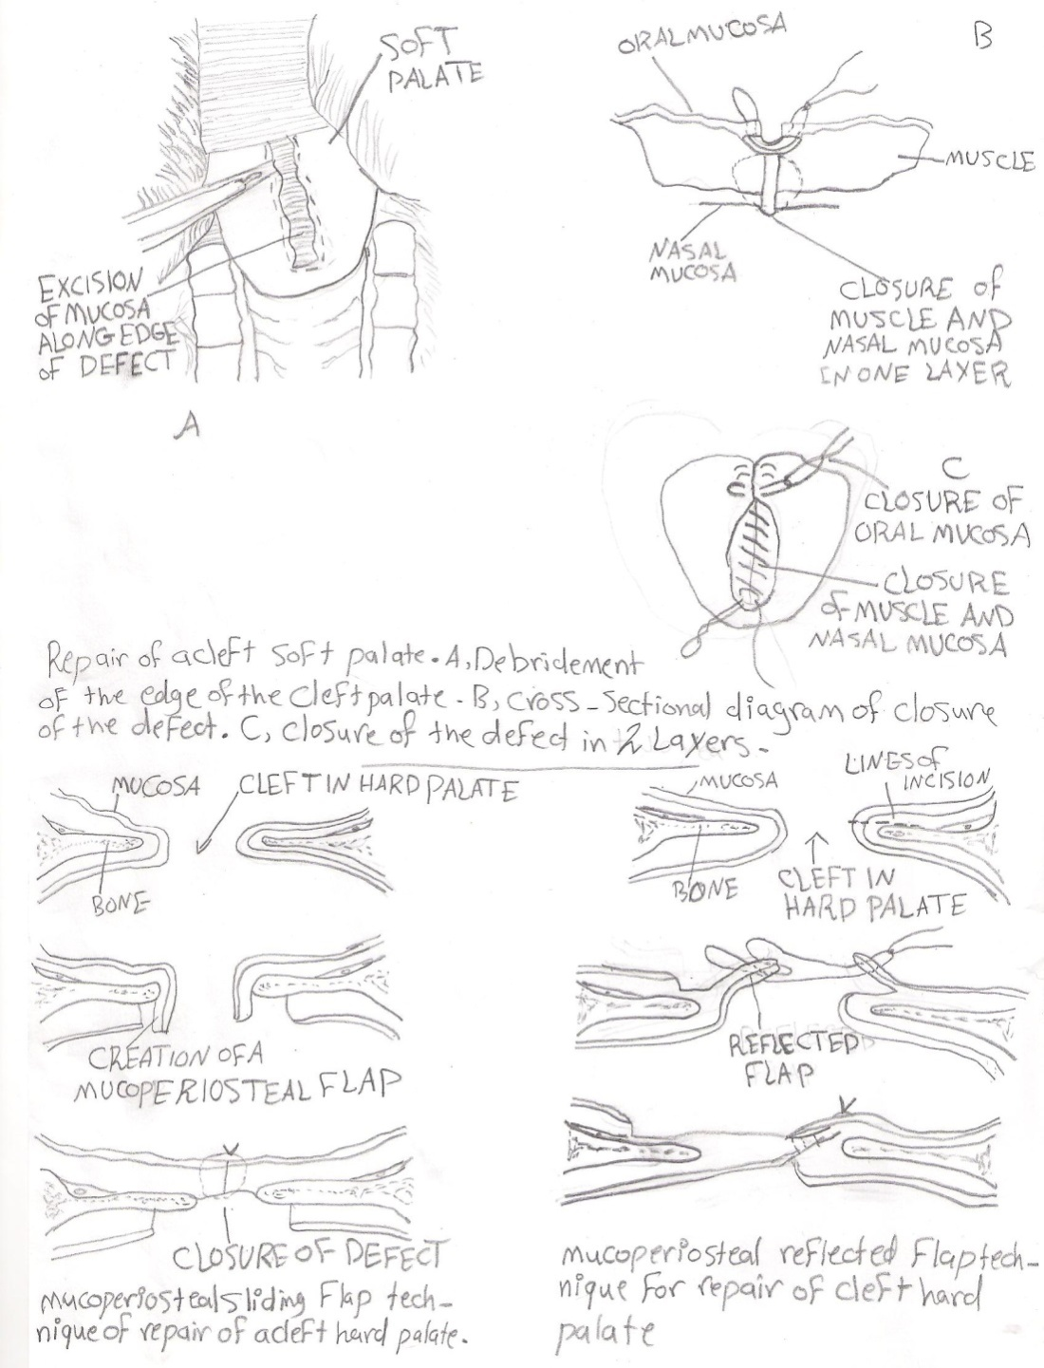

Soft palate: Musculomembranous fold that separate the cavity of the mouth from that of the pharynx. Mandibular – symphysiotomy approach was used. However surgical exposure of the caudal soft palate is still poor with this approach and the supplemental use of a midline pharyngotomy. The repair of a cleft soft palate involves excision of the mucosal edge surrounding the cleft following by a two or three layer closure. Possible complication of mandibular symphysiotomy includes infection and drainage as well as osteomyelitis and loosening of the symphysiotomy site.

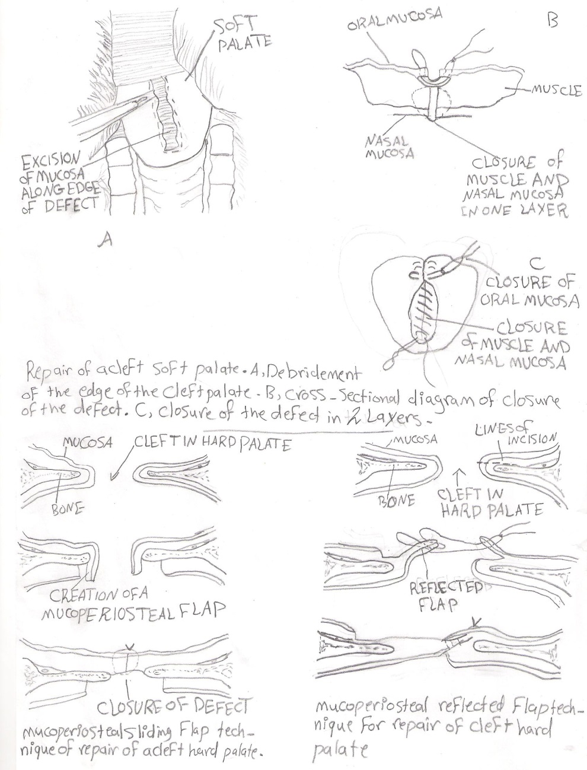

**Tongue:**The tongue is supported in a sling formed by the myeloid muscles. The root is attached to the hyoid bone, soft palate and pharynx. The tongue consists of mucous membrane, glands, muscles, nerves and vessels. The frenulum linguae pass from the lower surface of the free part of the tongue to the floor of the mouth.

|  |  |
| --- | --- |
| Affections of the tongue: |  |

Congenital affection:

1.Ankyloglossia: Congenital adhesion of the tongue to the floor of the mouth.

2.Biforcation tongue: Biforgation of the free end of tongue to avarilable distance caudally.

Acquired affections:

1.**Injuries**: various injuries to the mucosa or muscular of the tongue caused by abnormal tooth shape or position, bites, foreign bodies, spiny vegetation and fine thorns. The depth and extend of the injury determines whether an inflammation reaction (Glossitis) develops.

Clinical signs:

1. Reluctance and often inability to protrude the tongue for feeding.
2. Salivation.
3. Halitosis.
4. Pharyngeal lymph nodes are enlarged and painful.
5. Aspiration pneumonia is a common complication of dysphagia.

Treatment:

a. Fresh wound of the muscular should be cleaned and sutured.

b. Old wound cleaning and application of local antiseptics and antibiotics.

c. Large wounds of the tongue tip often heal badly due to the poor blood supply and constant movement and some become necrotic.

**2.Tumor**: Uncommon, but the one usually seen is sequamous cell carcinoma. Treatment is excision if possible or amputation where practicable.

**3. Fracture of hyoid bone**: The hyoid bone is occasionally fractured following sever traction on the tongue or in blunt trauma which also produce a mandibular fracture.

Clinical signs:

1. Sudden difficulty in mastication and deglutition.
2. Retropharyngeal swelling.
3. Epistaxis.
4. The tongue protrudes as a rule and may appear paralyzed.
5. dyspnea.

Treatment: Tracheostomy in sever dyspnea, fracture immobilization if possible by expose the fractured bone and wire the ends together. Forced feeding by stomach tube, long term feeding an indwelling oesophagostomy tube may be considered.

**4. Laceration**: Occur after street accidents or by sharp tooth fragments. If laceration is deep suture it under general anesthesia. Suturing should involve obliteration of dead space within the tongue substance. Tension suture on the dorsum of the tongue is more effective than suture placed on the ventral muscular portion.

**5. Foreign body:** In cattle sping vegetative and sharp bodies such as needle, wire may be penetrating the tongue.

**6. Snake bite:** The tongue can be bitten by a snake as it protruded to bring grass or hay. Most snakes have long teeth and strong protolytic or histolytic enzymes in their venom.

Clinical signs: a.Severe local reaction is set up in the tongue complicated by virulent bacteria inoculated by contaminated teeth.

b. Gangrene may occurs

c. Swell and protrude from the mouth.

Teatment: a. scarification of the tongue to drain exudate.

b. injection of antivenin and antibiotic.

c. water and feed are given through stomach tube.

d. in severe cases rumenostomy is performed to provide food and water.

7.Glossoplagia(paralysis of tongue): Its results from paralysis of hypoglossal nerve.

Etiology: a. central paralysis (rabies, brain tumor).

b. peripheral paralysis, result from contusion pressure and torn of nerve along its course.

c. fracture of mandible.

Clinical signs:

1. In bilateral paralysis: The whole tongue is flaccid and hands out of the mouth.
2. In unilateral paralysis: The tongue deviated towards the affected site, when extended and toward the affected site when retracted.
3. Salivation.
4. Mastication and swallowing of food are difficult or impossible.

Treatment: 1. Protection of tongue from injury.

2.nerve tonic.

3.sacrification.

8.Neoplasm: Very rare in domestic animals, treated by excision of lesion or amputation of the tongue.

**Procedure of partial Glossectomy:**

1. This is done under general anesthesia.
2. Bleeding is prevented by means of clamps placed transversely across the tongue or by the use of a tourniquet.
3. The tongue is divided in (V) shaped fashion, the base of the (V) pointing toward the tongue root.
4. The lingual artery and vein run on either side of the vertical middle partition. They must be secured and tied off with fine catgut. Release the tourniquet or clamp and either electro-coagulate or tie off any remaining bleeding point.
5. The two arms of the (V) shape are brought together and interrupted sutures of silk are deeply placed to unite them to give the shortened tongue a tapering point.

**Self – Suckling :**

The bad habit can be controlled by many methods:

1. Metallic tags: rings are sometimes inserted in the frenulum of the tongue to discourage self – suckling.
2. After the contour of the tongue by an elliptical incision is begun just anterior to the attachment of the frenulum. This incision should penetrate only through the thick mucosa, by approximately (2 inches) wide at the widest point and extend to about (1 inch) from the tip of the tongue. Simple interrupted suture of non-absorbable material is adequate for closure.
3. Partial Glossectomy: The goal of this procedure is to remove a portion of the tip of the tongue in a diagonal manner to prevent the animal from curling the tongue to nurse.

Procedure**:**

1. Stripe of gauze bandage can be wrapped around the base of the tongue both to act as a tourniquet and to aid in restraint for surgery.
2. Scalpel can be used to sever the tip of the tongue.
3. The edge can be brought together with absorbable interrupted sutures to appose the edges of the mucous membrane and aid in controlling hemorrhage.

Blood vessels: lingual artery , sublingual branch of the linguofacial trunk.

Nerve supply: glossopharyngeal nerve, hypoglossal nerve, vagus nerve and facial nerve.

**Salivary glands:**

In large animal parotid salivary gland was situated in the space between the ramous of the mandible and the wing of the atlas. The parotid duct opens into the mouth in the area of the third maxillary cheek teeth. The mandibular or sub – maxillary gland lies beneath the parotid gland and extends from the atlas to the level of canine teeth. The sublingual gland is situated beneath the mucous membrane of the mouth between the body of the tongue and the ramus of mandible and extends from the symphysis to the fourth or fifth mandibular cheek tooth. The sublingual ducts about thirty in number open on small papillae on the sublingual fold.There are four main pairs of glands in small animals:

1.Parotid salivary gland : located at the distal portion of auditory canal. The duct entering the mouth at the parotid papillae opposite the upper fourth premolar tooth.

2.Mandibular salivary gland : located ventral to the parotid gland. It lies in the fork formed by the linguofacial and maxillary vein. The mandibular duct opens on the floor of the oral cavity at the base of the lingual frenulum.

3-Sublingual gland: located in sublingual area, duct open with that of mandibular duct or separate exit.

4-Zygomatic gland (dorsal buccal gland in other animals): lying medial to the rostal end of Zygomatic arch. The duct opens caudal to that of parotid duct.

**Trauma**: Fresh wound involving the salivary glands can be sutured. When suturing is not practical, healing by granulation occur. However a permanent fistula may develop following trauma to a salivary duct. The fistulous tract has usually formed a fibrous tube, it should be excised by a circular incision around the fibrous wall cut this off close to the salivary duct. Introduce a polyethylene catheter into the duct, secure the end in the mouth with a few sutures and in the cheek and cut off the excess. Closure the wound in several layers with catgut. The skin wound is closed with interrupted silk sutures. The tube facilitates normal drainage of saliva.

2- **Sialotiths**: These usually occur in stensens duct (parotid duct) and can achieve considerable size. The calculi consist mainly of calcium carbonate and are considered to require a nidus ( small foreign body or inflammatory process ) for

deposition of the calcium salts. Enlargement due to the calculus is the usual clinical future. Radiographs can be used to confirm the presence of sialolith. Surgical operation can be done under general anesthesia, make an incision over the swelling along the course of the duct taking care to

avoid accompanying veins and arteries. Expose the calculus then remove it and suture the duct wall with continuous catgut suture .

3**- Salivary cyst (Ranula , mucocele)**: Rupture of a duct and leakage of saliva into the surrounding tissue to form fluctuant swelling diagnosis by aspiration of saliva on needle puncture . The D.D from thyroglossal cyst and cervical abscess .

Treatment: Fistula creation from cyst to the mouth by placing a Penrose drain,or radical excision of cyst and associated damaged Salivary gland.

4. Neoplasm’s: The parotid gland may be the seat of benign or malignant tumors. The commonest tumors in this region are melanomata, which often contain sarcomata's elements and are fond chiefly in grey horses. adenocacinomas of the parotid and mandibular gland are most common and occur in dogs horse and cattle.

Treatment: Benign tumor removes it by surgical operation; take care not to harm the important vein, artery and nerve in the vicinity. If it be malignant or diffuse. It is better not be intervenes.

5. Ectasia of salivary duct: It is dilatation of the stensons duct of parotid gland.

Etiology: 1. Congenital.

2. Obstruction by foreign body or calculi.

3. Scarring of orifice at the papillae.

Clinical signs: 1. Dilatation of duct over its course.

2. The swelling is soft.

Treatment: 1. In attempt to pass a probe through the orifice of duct.

2. Incision of the narrowed orifice with special scalpel.

3. Creation of artificial oral fistula into mouth cavity.

**Teeth**

Examination of the teeth not only is important for determining age but also help to identify abnormalities that might be present such as fractured teeth, sharp enamel and other lesion. The tooth was consist of the followings:

**Crown**: part of the tooth which appear over the gum.

**Neck**: area between crown and root.

**Root**: embedded in alveolar tissue which contain bl.v and nerve.

**The tooth consist of the following primary tissue:-**

1-enamel: calcified tissue cover the crown of the tooth other wholly or in part , hardest to protect the sensitive tissue of the tooth. It is made up of mineral salts (of calcium and magnesium) and keratin. It can withstand high pressure.

2.Dentine: Is yellow and is a bone-like material which is present along the full height of the tooth. It is enclosed by the enamel in the crown portion and cement in the root portion. Dentine can also be composed of living cells which show divisions with new cells being added to it regularly. Dentine**,** forms the greater part of the tooth under certain condition it may be resorbable by osteoclast.

3.**Cement**: provides insertion of the periodontal membrane fibers. is the layer present covering the root portion of the tooth. It is made up of mineral salts and water and is almost as hard as bone. Periodontal membrane or ligament - It consists of fibers which extend across the cement and anchor the tooth in the bony socket. They also allow a certain degree of movement while chewing thereby acting as shock absorbers. The periodontal member is made up of strong c.t which provide firm attachment to the cement, alveolar bone and gingiva.

4. Pulp: The internal cavity of the tooth which contain bl.v, nerves to supply the tooth, communicated with periodontal membrane through the dental apical foramen. The number of root canals may range from 1 to 3 depending on the type of tooth.

The alveolar bone from a socket accommodating the tooth. The gingiva is fibrous tissue covered by modified mucous member, that invests the alveolar process and the necks of the teeth and while intact prevents entrance of the bactria in to the alveolus.

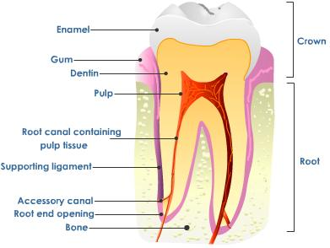

Common clinical signs of dental disease

1 – Difficulty in mastication.

2 – Quidding (drop of food out of the mouth in process of mastication).

3 – Weigh loss.

4 - Unilateral or bilateral nasal discharge

5 – Malodorous breath

6 – Swelling over the dental area

7 – Drainage from a fistula or sinus

8 – Sinusitis

9 – Reluctance to drink water

10 – Chewing of food on one side with tilting of the head

11 – Passage of un masticated food in feces

Diagnosis of dental disease:

1. Oral examination
2. Radiography
3. Endoscope if there sinusitis
4. Clinical signs

**Supernumerary Teeth (polydentia**)

Congenital condition leading to dental crowding usually in incisors.

Clinical signs : 1- malocclusion

2- Gingivitis

3- prehension difficult

4- Ulceration of tongue

Treatment : Extraction of these teeth .

**Oligodeutia**

It is a congenital absence of tooth germ or retention and inclusion of a tooth with in the jaw.

**Sharp teeth**

This condition occur due to irregular wear of teeth leading to painful lesion of buccal mucosa or tongue and cause disorder of mastication. The outer border of the upper and inner border of the lower of molar become sharp.

cause :

1. Upper jaw more wide than lower jaw.
2. Weakness of masetter muscles.
3. Painful lesion so grinding at specific area.

Clinical signs:

1. imperfect mastication.
2. ulceration of buccal mucosa or tongue.
3. prolong food intake.
4. fowl mouth odor
5. unchanged grain in feces.

Treatment: rasping

**Dental caries**

Decalcification of the hard tooth substance involving either crown, neck or root , may be superficially carries or deeply or penetrating to opening of pulp cavity leading to cavitation of tooth. cariogenic bacteria that produce acid from carbohydrate fermentation and in addition proteolysis enzymes of different kinds of bacteria both destroyed and attack organic substance of tooth .Also defiance of fluorine play important role of this disease .

Clinical signs**:**

1. Brown to greyish brown or black discoloring.
2. Pain.

Treatment :Removal of brown substance then falling the cavity with inert substance e.g. : amalgam

**Dental tartar (calculus)**

Deposition of material on tooth surface which acts as nucleus for tartar formation due to calcified of material by mineral salts of saliva especially cal. phosphate, calcium and magnesium carbonates and organic substance. Tartar does not cause any clinical signs unless it involves the gingival border in which case primary marginal gingivitis may cause separation between gum and tooth, leaving a hollow to collect fecal particles lead to periodontal disease .

clinical signs **:**

* 1. Fowl smelling
  2. Yellow debris (or black, brown) packed around the teeth.
  3. gingivitis

Treatment: 1-removal of tartar by tooth scaler.

2-removal by H2O2 1:5 mouth wash.

HCL 1:100 mouth washes.

**Alveolar periostitis**

The alveolar periosteum is a vascular layer of c.t that attaches the embedded part of the check tooth to the alveolus. Inflammation changes in the area with secondary of bone enlargement, fistulation and sinusitis.

Causes :

1- The most common routes of infection include entrance of food material and resultant of infection through a patent infundibulum between the gum and tooth. 2- Association with fractured of tooth .

Clinical signs: typically consist of firm circumscribed swelling on the side of the face or the ventrolateral surface of the mandible.

**Treatment** : 1- antibiotic.

2- Extraction.

Indications of teeth extraction

1. Dental fistula originating from the root of an infected cheek tooth.
2. Sinusitis associated with diseased maxillary cheek tooth.
3. Fractured tooth with septic alveolar periostitis and osteomyelitis.
4. Neoplasia, abscesses or fractures of the mandible or maxilla.

Repulsion

Trephination and tooth repulsion, this is indicated whenever a tooth cannot be extracted.

Dentigerous cyst

The lesion appears as a fluctuant swelling at the base of the ear in a young horse , often accompanied by a discharging fistula. The tooth is usually associated with the temporal bone of the skull. Radiographs can be used to as certain the presence of a tooth and its position.

Treatment: The tract and cyst are completely removed. The tooth is attached to the temporal bone and the attachments need to be cut or broken.

Tooth extraction

Under general anesthesia a dental extractor is placed on the tooth and lateral to medial motion applied. When the tooth loosens in the alveolus, there is a sucking noise and rotary motion may then be used to help elevate the tooth. Following removal any debris show be removed from the socket, but the clot is left undisturbed. The cavity is flushed and a gauze pack inserted. This may be replaced with dental wax.

Brachygnathia: Shortened lower jaw (Parrot mouth).

Prognathia: Shortened of upper jaw.

Esophagus

In horse is (125 – 150 cm) in length and can be divided into cervical , thoracic and abdominal portion. The oesophagus begins in the median plane above the cranial border of the cricoid cartilage of the larynx. It is positioned dorsal to the trachea until it reaches the 4th cervical vertebrae where it descends obliquely across the left side of the trachea. It usually reaches the median plane ventral to the trachea at the caudal aspect of the 6 cervical vertebrae and enters the thorax in thin position within the thorax, the oesophagus re-assume a position dorsal to the trachea and passes right and then left again to the oesophagus hiatus of the diaphragm and terminates of the cardiac orifice of the stomach, slightly to the left of the median plane.

The oesophagus in bovine, in the cranial third of the neck the oesophagus lies dorsal to the trachea in groove formed by the longus coli muscle at the third cervical vertebrae the oesophagus inclines to the left surface of the trachea and maintains this relation until it reach the 6 cervical vertebrae, where it stops dorsal slightly to the dorso – lateral surface at the thoracic inlet.

Blood supply:

1. Cervical part (carotid artery).
2. Thoracic end abdominal part bronchoesophageal gastric arteries.

Nerve supply:

1. Gastropharyngeal.
2. Vagus .
3. Sympathetic trunk.
4. Mesenteric plexus.

The oesophageal wall is composed of four layers:

1. Fibrous sheath (Tunica adventitia).
2. Tunica muscularis.
3. Submucosa.
4. Mucosa.

Choke (Obstruction):

Obstruction of the oesophagus occurs in all animals, but is common in bovines, which very prone to pick up foreign bodies and bolt them, especially during pregnancy. In cattle (potatoes, beets and other vegetables roots), in dogs and cats bone fragments like fish bone. There are certain predilection sites for the feed to cause blockage, these are at the pharyngeal entrance to the esophagus, as the opening is bigger than the lumen more distally. As the thoracic entrance occasionally at the aortic arch, as the 1st rib and the aorta limit oesophageal distention , and the cardiac, where sphincter tone diminishes the lumen.

Clinical signs:

1. Tendency to stretch the neck.
2. Salivation.
3. Ruminal tympany.
4. Water cannot be swallowed .
5. Swelling may be seen in the left jugular furrow.
6. In horse may show sever distress by excitement, anxiety, sweating, shaking the head and walking about the stall .

Diagnosis:

1. Clinical signs.
2. The presence of an obstruction is confirmed by stomach tube.
3. X – Ray.

Treatment:

1. Medical by :
   1. Fluid therapy.
   2. Tranquilizer.
2. Manipulative treatment by :
   1. Foreign body at the pharyngeal entrance, manual removal under heavy tranquilization .
   2. If the foreign body is not too far from the pharynx , a wire loop can be inserted and manipulated over the body and gently withdrawn .
   3. If the object can be palpated in cervical area it may be possible to restrain the animal and retrieve the object manually from the oesophagus. If failed may pass stomach tube and try to push the object into the stomach .
3. Operative treatment: the musculature of the oesophagus is weak and holds sutures poorly, but the mucosa is relatively strong .

Oesophagotomy:

1. Under g.a. in small animals and equine, local anesthesia with sedation in ruminant. The animal was placed in dorsal recumbency and the ventral aspect of the neck surgically prepared.
2. (8 – 10 cm) skin incision made on ventral midline over the area of obstruction.
3. The paired sternohyoideus and omohyoideus muscles are divided to expose the trachea .

4. The fascia on the left side is then bluntly dissected to locate the oesophagus. The oesophagus either exposes between the trachea and sternocephalic muscle or between this muscle and vena jugularis. The stomach tube introduces to identify the oesophagus from other structure. Elevation of the oesophagus was avoided to minimize interference with blood supply. The left carotid sheath containing the carotid artery, vagus and recurrent laryngeal nerves are identified and retracted laterally.

Oesophagotomy was performed using a scalpel to incision in normal oesophagus wall. Following removal of the foreign body, the mucosa was closed with (2 – 0) or (3 – 0) polypropylene in simple interrupted or continuous pattern. The knots are tied within the lumen. The muscle was closed with polygalactine. The muscle and fascia of the neck incision were closed with polyglactine in a simple interrupted pattern. The skin was closed in a simple interrupted pattern with non-absorbable suture material .

Complications of Oesophagotomy:

1. Dehiscence of incision.
2. Infection (extension into surrounding tissue).
3. Fistula.
4. Stricture.
5. Leakage.
6. Diverticulum.
7. Dilation.
8. Laryngeal hemiplegia.

Oesophageal Diverticulum:

There are two types of oesophageal diverticula :

1. Traction diverticula: result when contraction of perioesophageal fibrous scars tissue causes outward traction and tenting of all layers of the oesophageal wall. They commonly develop at the site of a healed oesophagostomy or following spontaneous healing of an oesophageal wound or fistula.
2. Apulsion Diverticulum: is a local protrusion of mucosa through the oesophageal musculature. Although two mechanisms described foe the development of apulsion diverticulum is fluctuations in oesophageal intra – laminal pressure and overstretch damage to oesophageal muscle fibers may impacted feed stuffs.

Clinical signs:

Diverticulum of the cervical oesophagus will typically present with an enlargement in the neck that results in dysphagia or choke. The swelling may increase in size in association with swallowing.

Diagnosis:

1. Contrast media.
2. Endoscopy.

Treatment:

Repair of apulsion Diverticulum is diverticulectomy. The oesophagus is exposed and the Diverticulum identified the edges of the ruptured tunica muscularis are dissected from the mucosa, being careful to avoid penetration of mucosa, the mucosal sac is inverted and the debrided edges of the tunica muscularis sutured together with simple interrupted suture.

**Oesophageal stricture**:

The oesophageal wall layer involved in the duration and fibrosis mural lesion involves adventitia and muscularis. Ring lesion involves mucosa and sub mucosa annular lesion all layers of oesophageal wall.

Etiology:

1. External or Internal trauma.
2. Local pressure necrosis of the mucosa.
3. Oesophagotomy or perforation.
4. Sever oesophagitis due to caustic anthelminities or any other inflammatory process involving the oesophageal wall.

Clinical signs: manifested typical signs of oesophageal obstruction .

Diagnosis:

1. Clinical signs.
2. Endoscopy.
3. X – Ray.

Complications :

1. Aspiration pneumonia.
2. Dehydration.
3. Diverticulum.
4. Oesophagotracheal fistula.

Treatment:

1. Use of bougienage to dilate annular lesion.
2. Surgically method includes oesophagotomy or partial resection.

**Narrowing of the Oesophagus**:

Caused by other than f.t. formation in the wall of the oesophagus itself including:

1. Neoplasia .
2. Abscessation of the wall of oesophagus.
3. Exstraoesophageal lesion such as abscesses neoplasia, goiter, scar tissue and sequel to a wound.

Diagnosis:

Indicated by a tendency for ingesta to delay or to accumulate in the oesophagus. If the narrowing is in the cervical region, it can frequently be seen by the bulge of a bolus cranial to it or detected by palpation. Differentiated from stricture within the oesophagus by clinical, radiology and endoscopic exam.

Treatment: According to the cause.

Perforation or rupture of oesophagus:

Break down into oesophageal wall can occur secondary in long – standing obstruction, foreign body perforation and external trauma to the cranial area or extension of infection. If there is no drainage to the outside, the leakage of saliva and ingesta into the tissues of the neck cause severe cellulitis and phlegman development.

Treatment:

1. When there is drainage in the oesophageal wall and or significant infection of the surrounding tissue, it is better to leave the defect to heal spontaneously, while providing adequate drainage and placing an oesophagostomy tube aboral to the defect. The animal is fed through the tube.
2. Resection and anastomosis.

Megaoesophagus:

Dilation of the oesophagus resulting from hypomotility unassociated with an anatomical lesion or obstruction. The authors suspected that the problems was achalasia (generalized) neuromuscular dysfunction and enlargement of the oesophagus with narrowing of distal portion.

Diagnosis:

1. Clinical signs.
2. Radiography.

Treatment: Oesophagomyotomy.